**Exercise 1:**

1d 2a 3c 4b

**Exercise 2:**

HTML:

<!DOCTYPE html>

<html lang="en">

<head>

    <meta charset="UTF-8">

    <meta name="viewport" content="width=device-width, initial-scale=1.0">

    <link rel="stylesheet" href="index.css">

    <title>Document</title>

</head>

<body>

    <div id='msg'>Hello</div>

    <script src="index.js"></script>

</body>

</html>

JS:

let d = document.getElementById('msg');

setInterval(() => {

    d.insertAdjacentHTML("beforeend",

        `<div>Life is pain</div>`)

}, 3000)

//'Life is pain' is added every 3 seconds

**Exercise 3:**

3.1 No  
3.2 Still no

**Exercise 4:**

HTML:

<!DOCTYPE html>

<html lang="en">

<head>

    <meta charset="UTF-8">

    <meta name="viewport" content="width=device-width, initial-scale=1.0">

    <link rel="stylesheet" href="index.css">

    <title>Document</title>

</head>

<body>

    <ul>

        <li>Wind</li>

        <li>Water</li>

        <li>Fire</li>

        <li>Earth</li>

    </ul>

    <script src="index.js"></script>

</body>

</html>

JS:

let d = document.getElementsByTagName("li");

for (i=0;i<d.length;i++) {

    console.log(d[i].textContent);

}

Results:

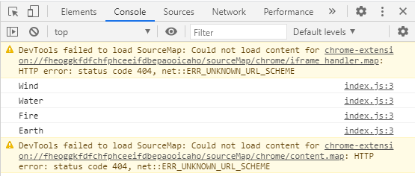

**Exercise 5:**

HTML:

<!DOCTYPE html>

<html lang="en">

<head>

    <meta charset="UTF-8">

    <meta name="viewport" content="width=device-width, initial-scale=1.0">

    <link rel="stylesheet" href="index.css">

    <title>Document</title>

</head>

<body>

<div>

    <div class="element">Wind</div>

    <div class="element">Fire</div>

    <div class="element">Water</div>

    <div class="element">Earth</div>

</div>

    <script src="index.js"></script>

</body>

</html>

JS:

let d = document.getElementsByClassName("element");

for (i=0;i<d.length;i++) {

    console.log(d[i].textContent);

}

Results:

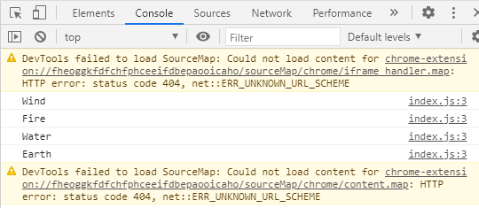

**Exercise 6:**

HTML:

<!DOCTYPE html>

<html lang="en">

<head>

    <meta charset="UTF-8">

    <meta name="viewport" content="width=device-width, initial-scale=1.0">

    <link rel="stylesheet" href="index.css">

    <title>Document</title>

</head>

<body>

    <div>

        <ul>

            <li>Wind</li>

            <li>Fire</li>

            <li>Earth</li>

            <li>Water</li>

        </ul>

        <button onclick="deleteLi()" style="position: fixed;">Delete the 1st element</button>

    </div>

    <script src="index.js"></script>

</body>

</html>

JS:

let d = document.getElementsByTagName("li");

function deleteLi() {

    d[0].remove();

}

**Exercise 7:**

7.1   
e.target is the line(s) of HTML the id belonged to.

7.2  
e.key is the key(s) that the user inputted into the input box.